|  |
| --- |
|  |
| Figure 0: Mean CBF values sampled from the WM surface for all 40 subjects (by color) according to ASL axial slice number (proportional to distance superiorly from the perfusion tag location). |

Figure 1. Desikan-Killiany (2006) (DK) parcellations in the gray matter (GM) (A), white matter (WM) (B), and in lateral (C) and medial (D) view of the inflated GM/WM boundary of the left hemisphere of a subject. The yellow contour shows the GM/WM boundary in A, B, and C. Light gray and dark gray shows the gyri and sulci structure in C and D along with the DK parcels in colored outline.

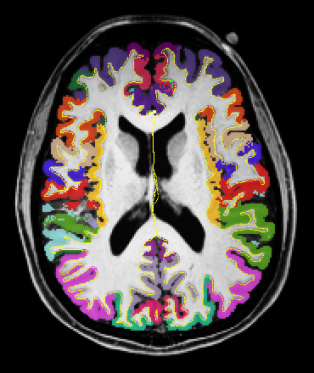 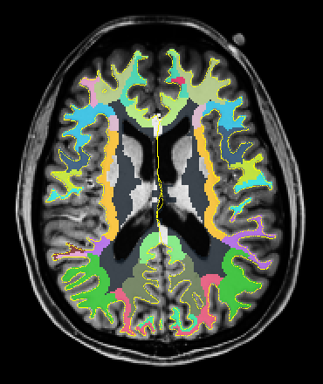

A B

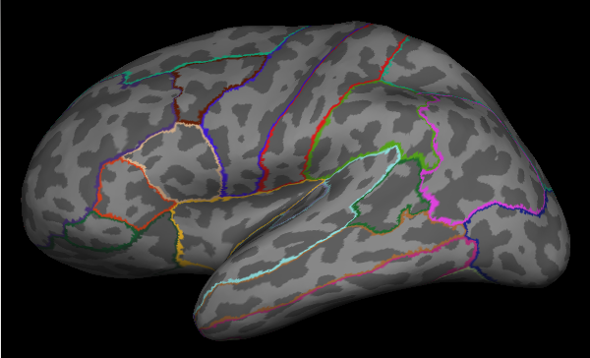 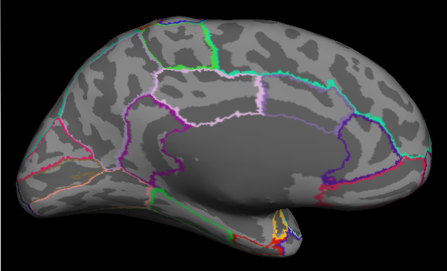

C D

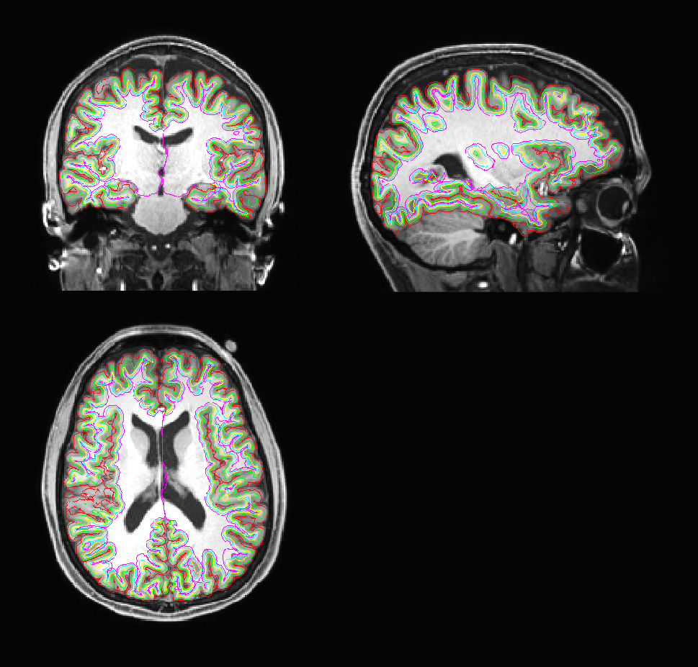 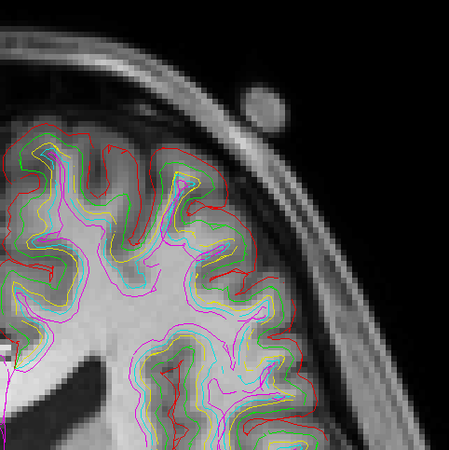

A B

Figure 2. Five segmented surfaces in A of a subject: Sp (Red) — pial surface, the surface between GM and CSF; S0 (Yellow) — the boundary between WM and GM; Sm (Green) — middle of GM, i.e., the middle surface between S0 and Sp; S-1 (Cyan) and S-2 (Magenta) — 1 mm and 2 mm inside the WM below S0. The yellow squares in A were enlarged in B.

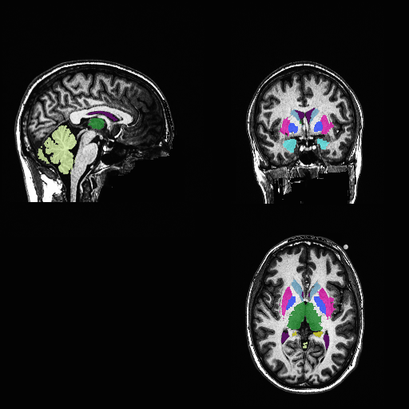

Cerebellum

Ventricle

Thalamus

Caudate

Putamen

Pallidum

Hippocampus

Amygdala

Figure 3. Segmentation of subcortical structures for a subject by FreeSurfer. The labels indicate the structures on the right hemisphere.

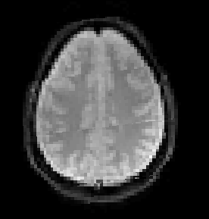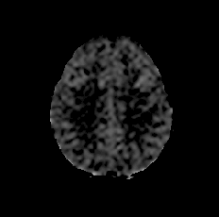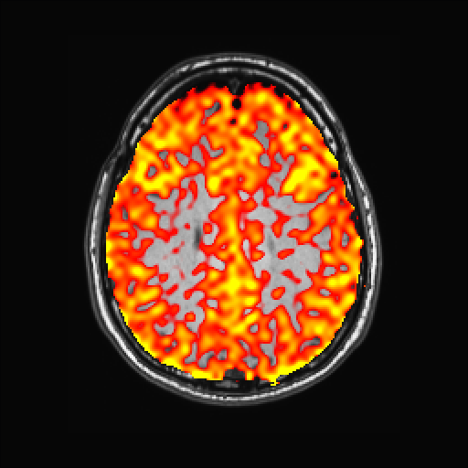

A B C



100

20

0

Figure 4. Raw pCASL control image (A), CBF image (B, *ml/100g/min*) in high resolution anatomical space, and mapping image (C) of the CBF data on the anatomical image for a young control subject.

LH CBF Reductions (%) RH

MC – YC AC – YC MC – YC AC – YC

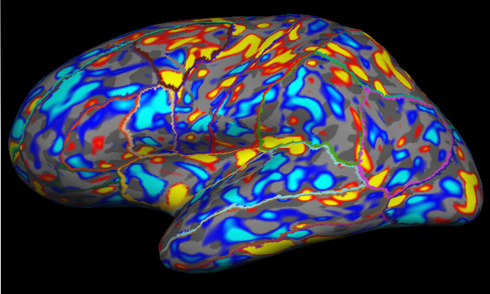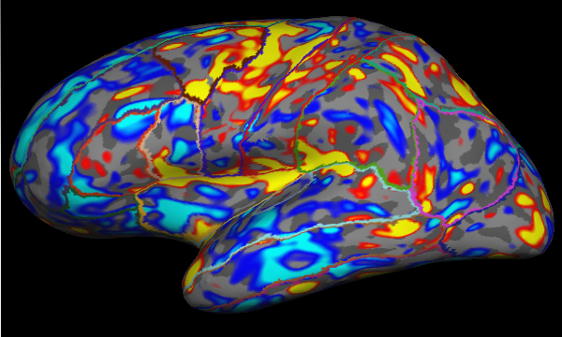 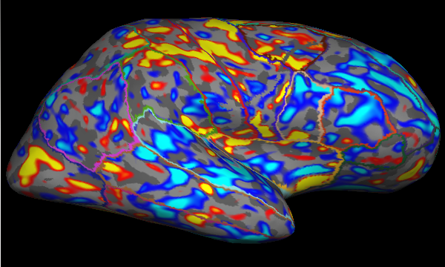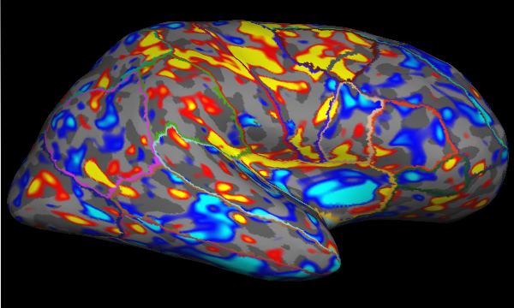

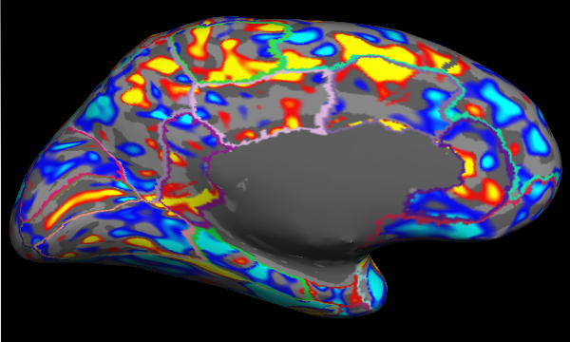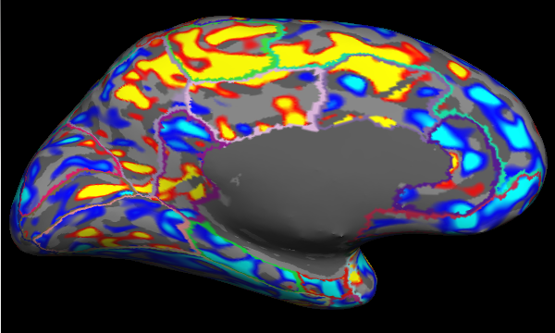 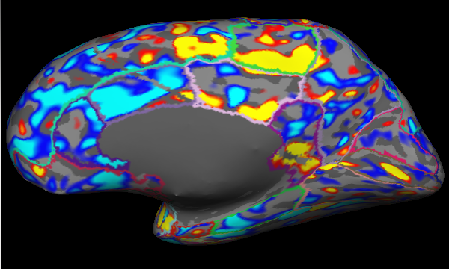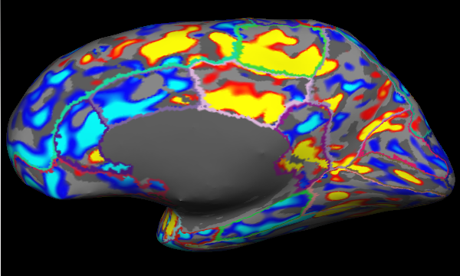

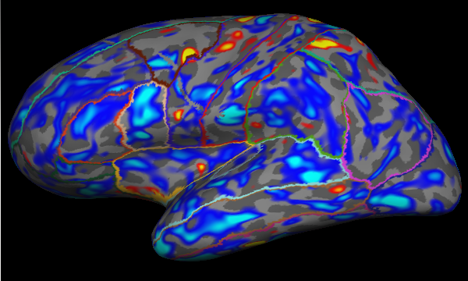 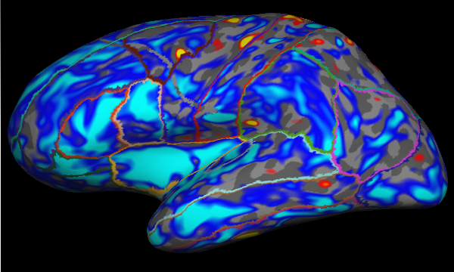 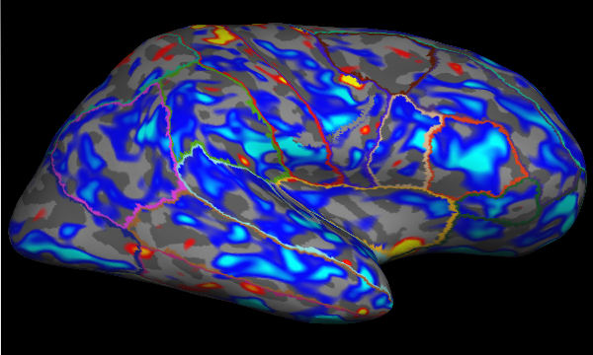 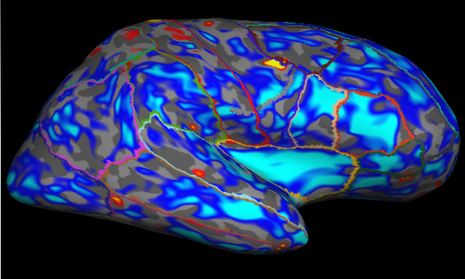

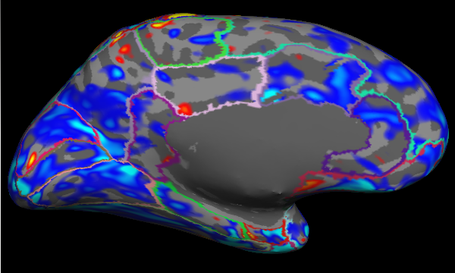 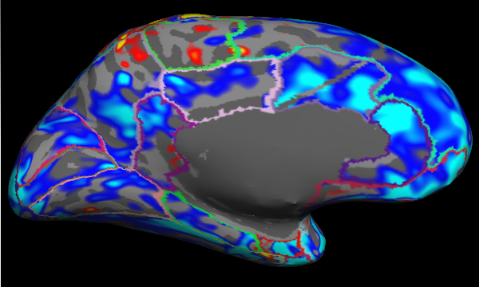 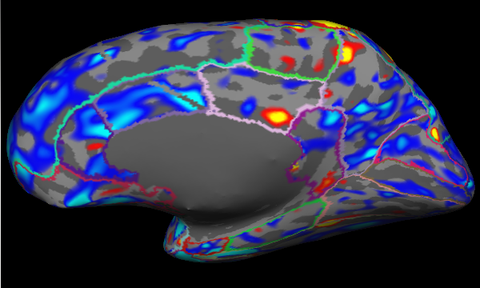 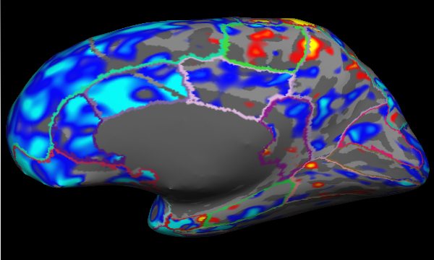



60

10

0

-10

-60

Surface S-2

Surface Sm

Figure 5. Cerebral blood flow (CBF) reduction of middle aged (MC) and aged (AC) control subjects compared to the young (YC) control subjects for left (LH) and right (RH) hemispheres on the surface S-2, 2 mm inside WM from the GM/WM boundary and the mid-GM surface Sm. The color contours are the Desikan-Killiany parcellations. Blue values show the CBF reduction.

CBF Asymmetry Index (%)

YC MC AC

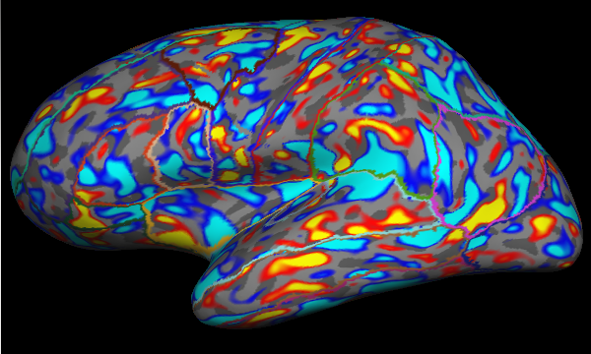 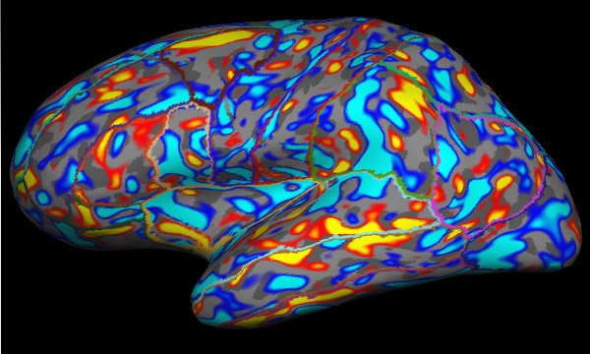 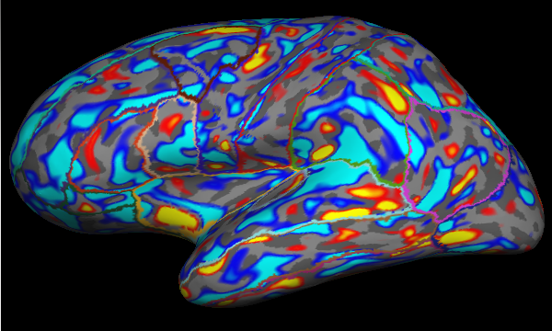

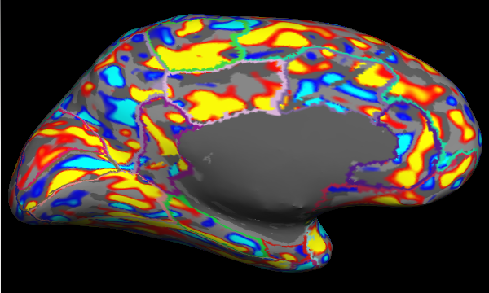 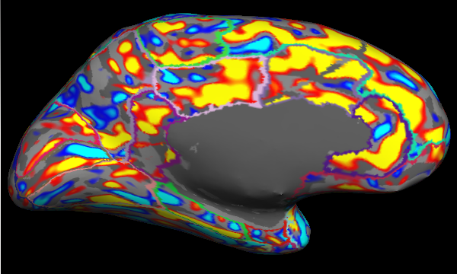 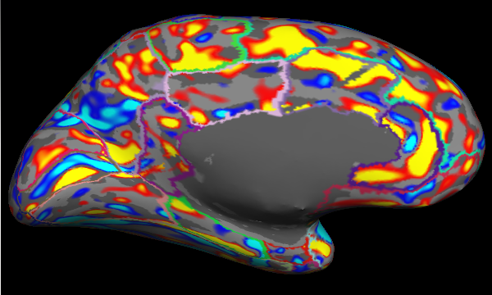

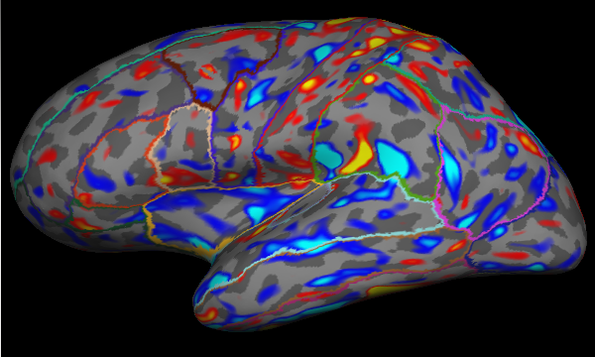 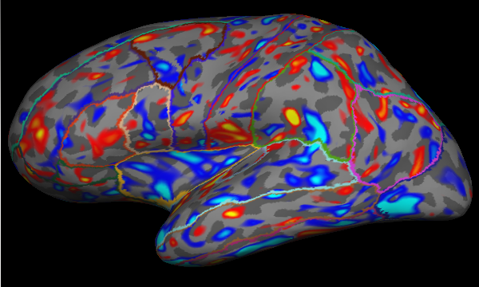 

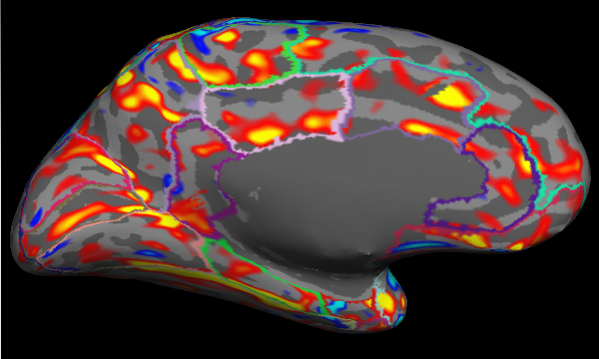 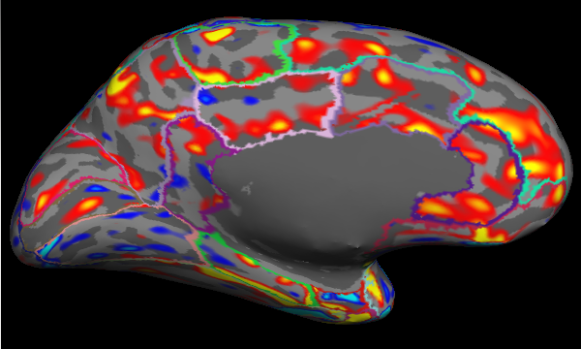 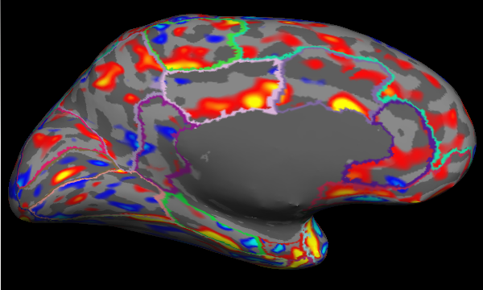



60

10

0

-10

-60

Surface S-2

Surface Sm

Figure 6. Cerebral blood flow (CBF) asymmetry index (AI) for young (YC, left column), middle aged(MC, middle column) and aged (AC, right column) control subjects on the surface S-2 2 mm inside WM from the GM/WM boundary and the mid-GM surface Sm. The color contours are the Desikan-Killiany parcellations. Red values means LH > RH, blue values LH < RH.

Figure 7. Cerebral blood flow (CBF) reduction in percentage for middle aged (MC, A) and aged (AC, B) control subjects compared to young control (YC) subjects on the surfaces from S-2, 2 mm inside the WM, to Sp, the pial surface.

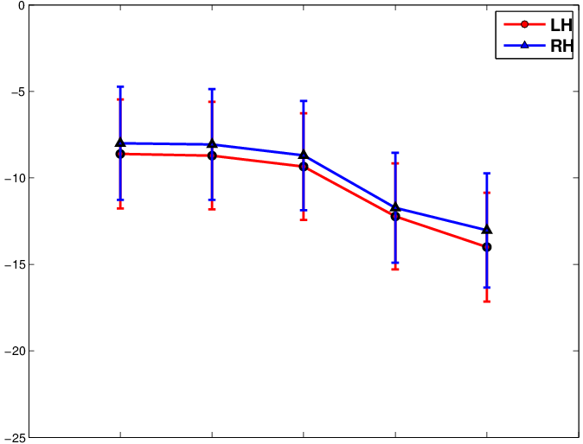 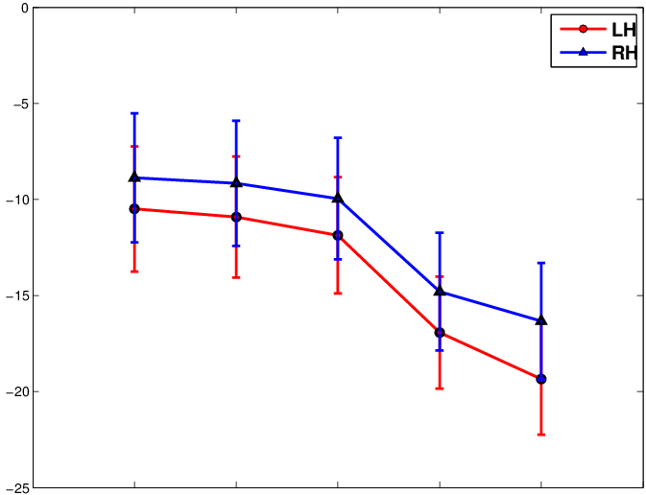

S-2 S-1 S0 Sm Sp S-2 S-1 S0 Sm Sp

1. (MC – YC )/[(MC+YC)/2] x100% B. (AC – YC )/[(AC+YC)/2] x100%

(a)

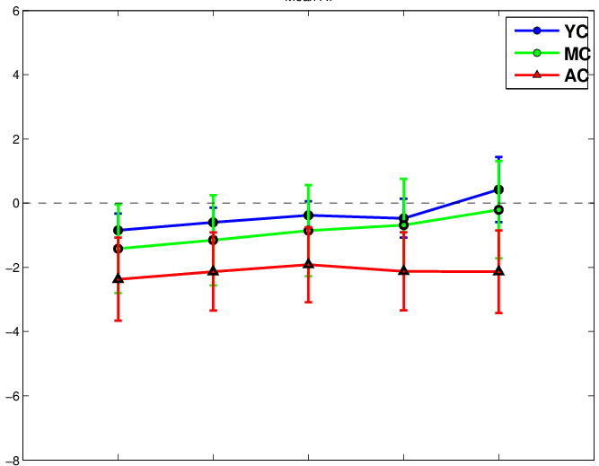

S-2 S-1 S0 Sm Sp

AI (%)

Figure 8. Asymmetry index (AI, %) of young (YC), middle aged (MC) and aged (AC) control subjects on the surfaces from S-2, 2 mm inside the WM, to Sp, the pial surface.

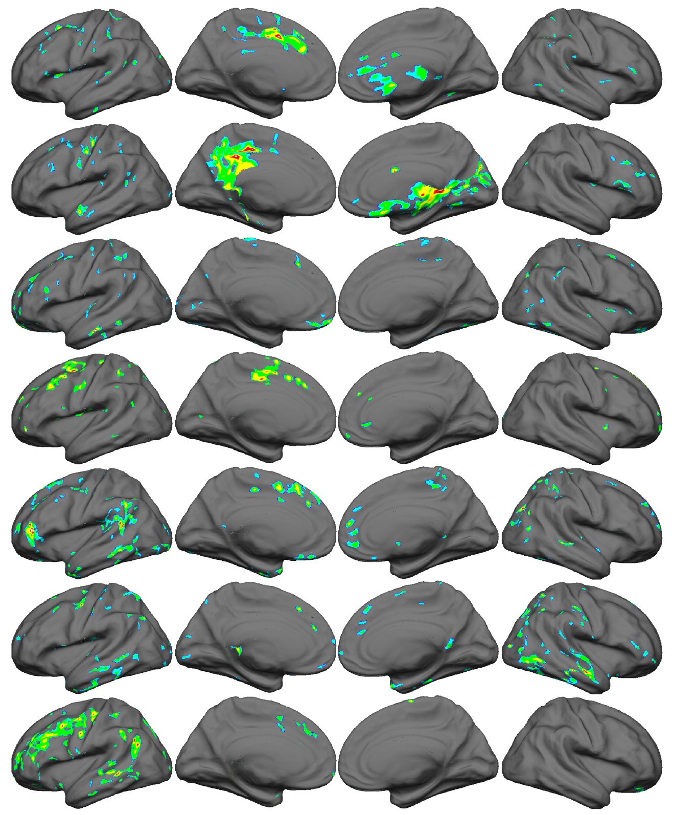

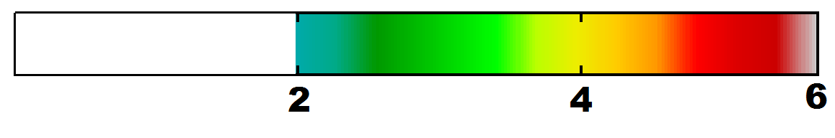

(b)

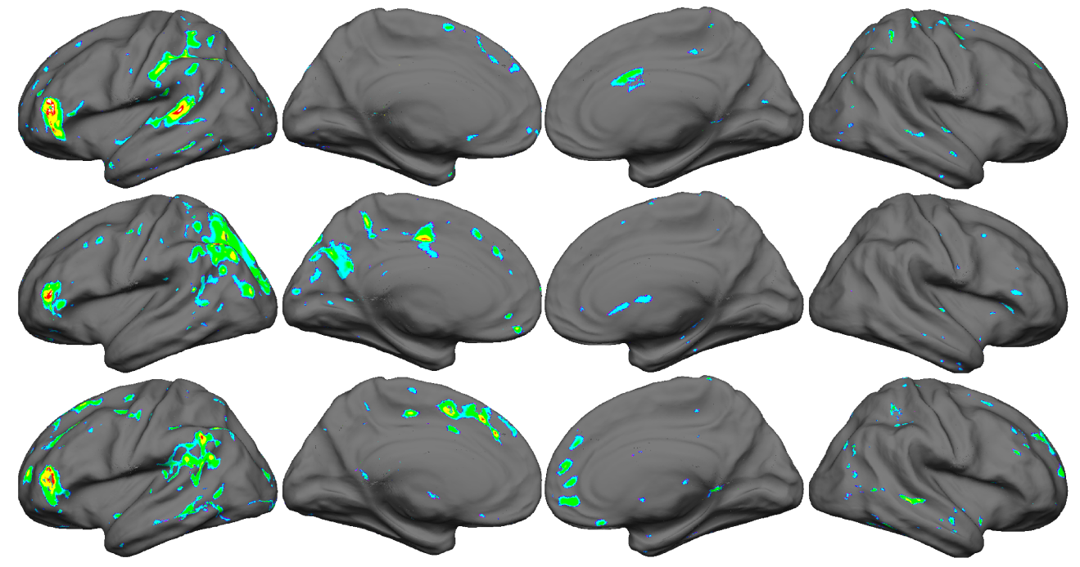



Figure 9: (a) Seven chronic LH stroke patients (rows: patients S01, S02, S03, S05, S07, S08, S10) cortical mid-GM CBF deficit compared to MC+AC control subjects. Rows are different views of hemisphere (left on left) and view (lateral as lateral). Z scores from 2 to 6 in clusters of 20mm or more shown with the z-normalized and covariate adjusted CBF scores being used. (b) One stroke patient (S07) imaged at at 5 mo. (top row), 13 mo. (middle), and 25 mo. (bottom) post-stroke with infarcts affecting left lateral prefrontal, left insula, left posterior temporal, and connecting WM.

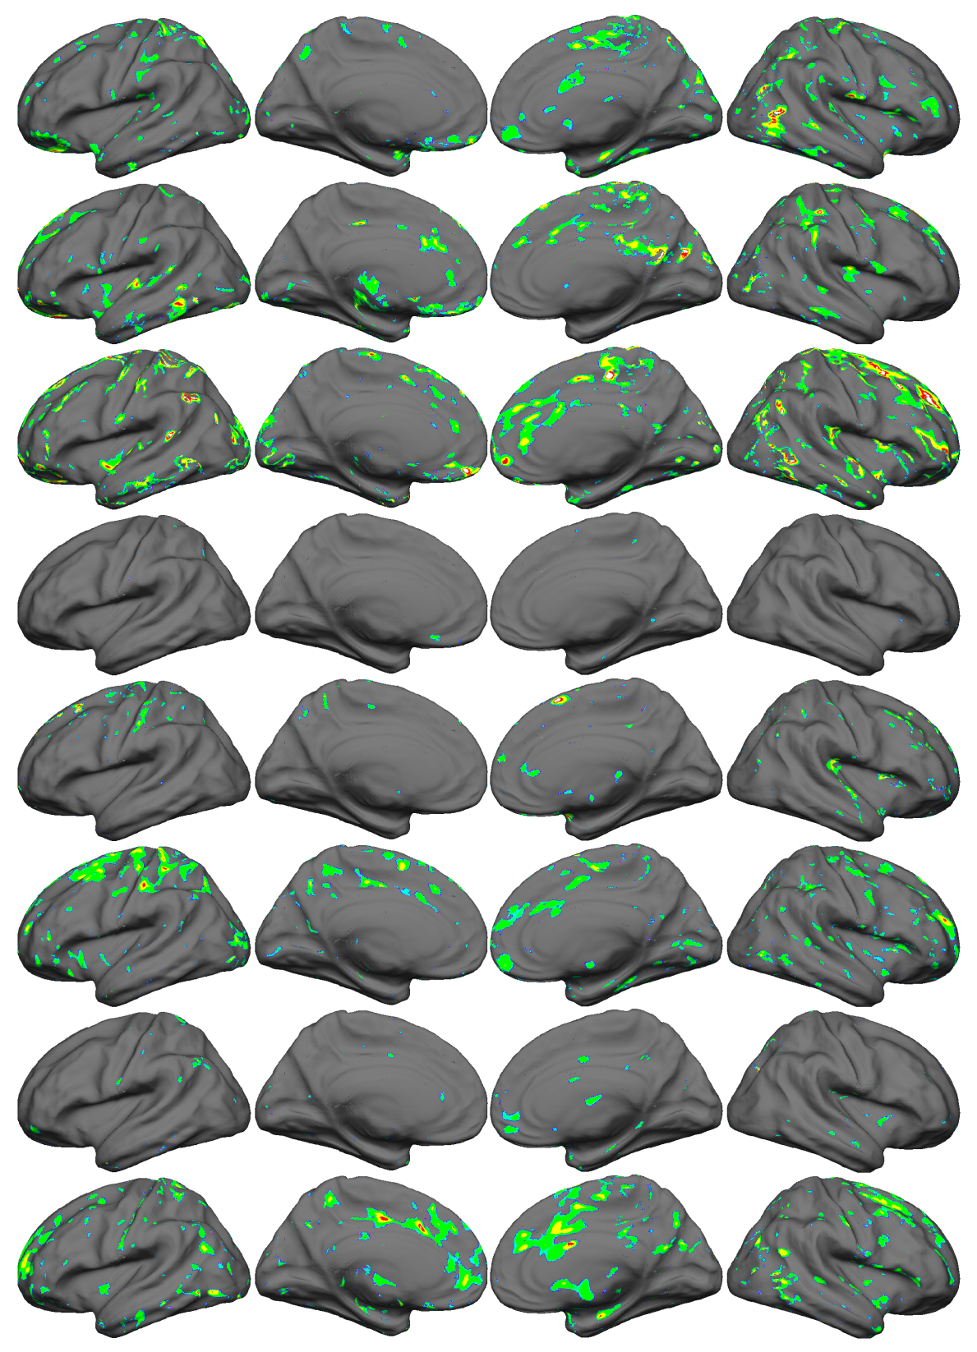

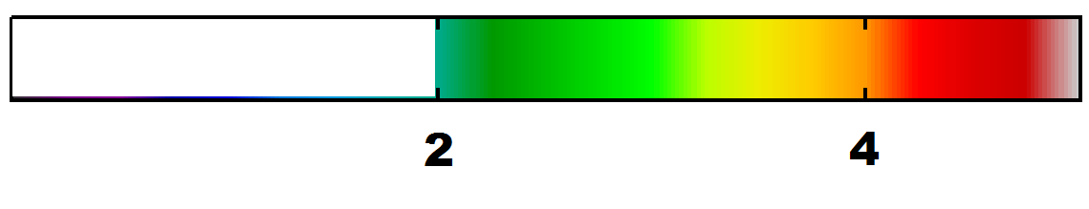 Figure 10: Eight chronic TBI patients (rows: patients S13, S14, S15, S16, S17, S18, S19, S21) cortical mid-GM CBF deficit compared to MC+YC control subjects. Rows are different views of hemisphere (left on left) and view (lateral as lateral). Z scores from 2 to 5 shown with covariate adjusted CBF scores being used.